**DBMS** **SKILL-2**

**PRE-LAB**

1. What is an entity? Also write the difference between strong entity and weak entity?

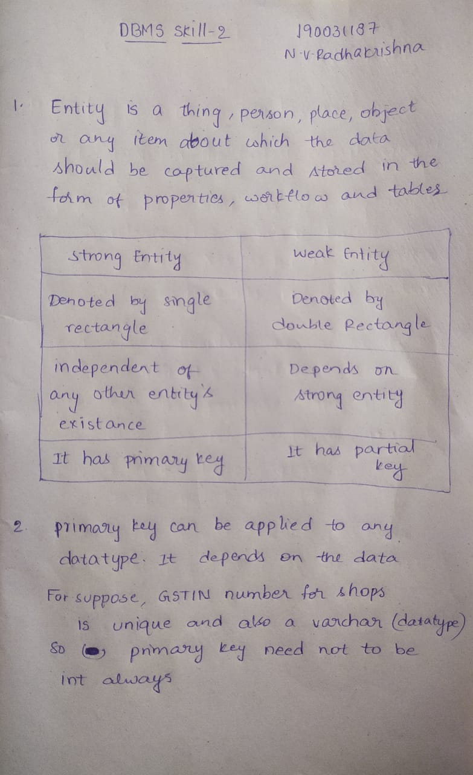

1. Does Primary key can be applied only on int data type or on any data type also, justify your answer?



1. How is alternate key different from primary key?

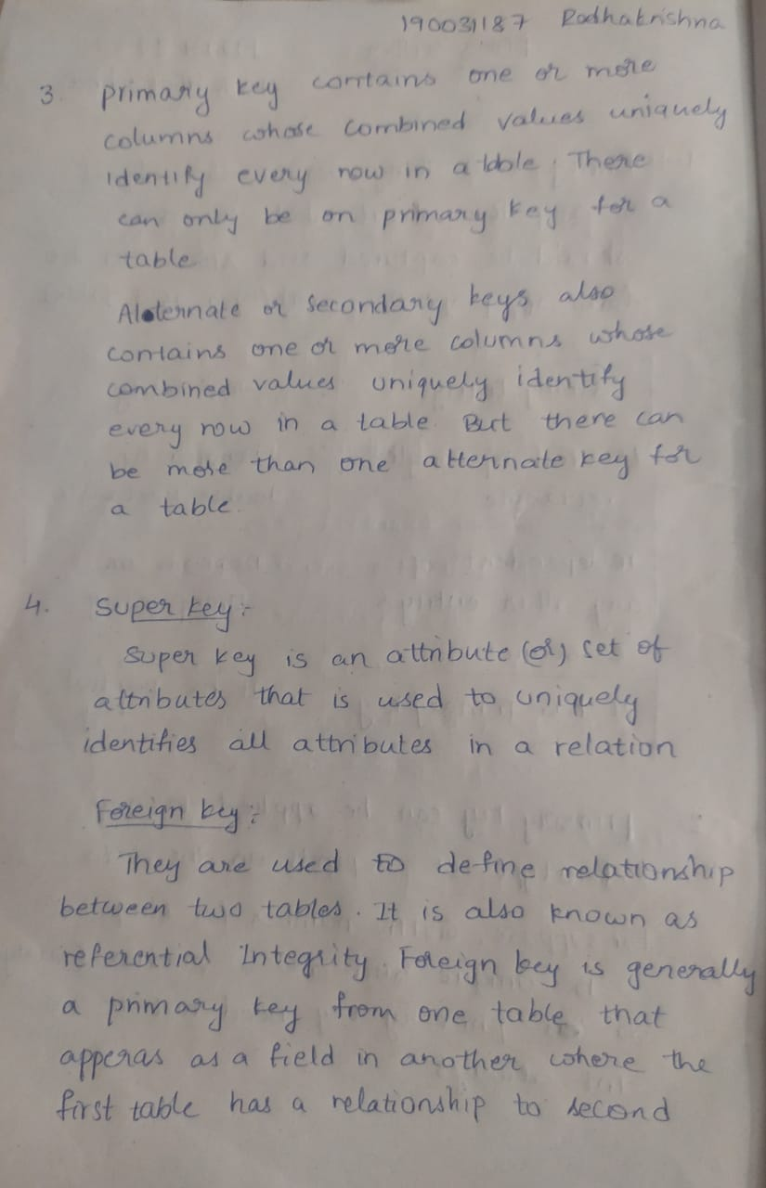

1. What’s the difference between Super key and Foreign key?



1. What is a strong relationship and how is it depicted in a crow's foot ERD?

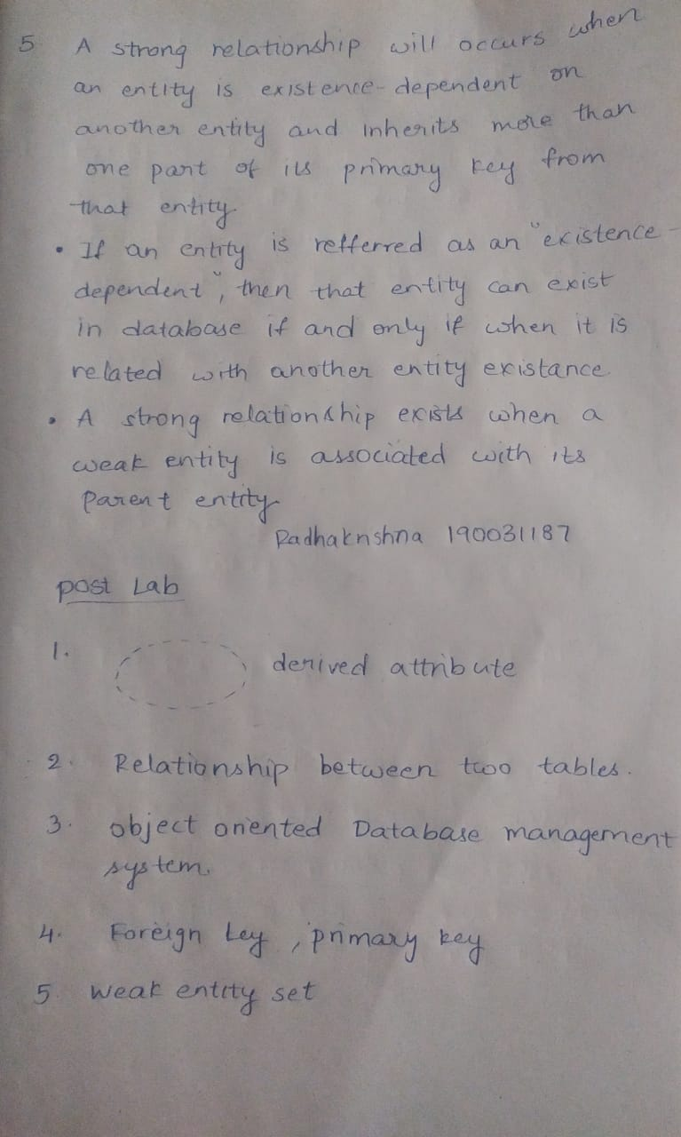

IN-LAB

**CASE STUDY 7: PROPERTY RENTAL INFORMATION SYSTEM**

**Draw an ER Diagram for the given case study**

Our company arranges rentals of properties owned by both private and business owners. We assign every property owner a unique owner number for identification, we record its address (consisting of a street, street number, town or city, and province), the owner’s name (consisting of first, middle, and last name for a person or name of a business), and the owners email addresses and the owner phone numbers. For a business owner, we record the type (description) of its business. Each property is identified by a unique property number, we record its address and its type. Each property may be placed in several advertisements. Each such advertisement may be displayed in many newspapers on several dates. The newspapers are identified by unique names.

The term renter refers to a private person or a business who signed a rental agreement for a property. Each such rental agreement is identified in our database by a unique rental number. We record the date of the signing of the rental agreement, the starting and ending date of the rental agreement. A renter can rent many properties. A renter, prior to accepting the rental agreement may view the property repeatedly and we record the date of viewing. For each renter, we record its address, its name, its email address and phone numbers. Each renter has a unique renter number in our database.

Our agency is organized into branches and every staff member is allocated to exactly one branch. Each branch has one manager who is a member of the staff. In our database, we identify the staff by a unique staff number. For each staff member we record address, name, email address, phone numbers, sex, position, and salary. Each property is in care of one of our branches. Each renter refers to the branch that is in care of the property it rents. Each property is overseen by a unique staff member. Each branch has an address, phone number, and a unique branch number.

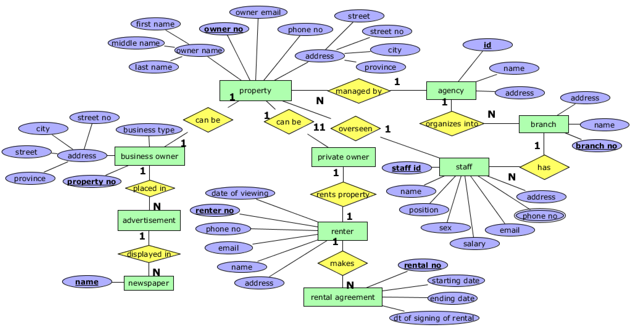

**POST-LAB**

1) What is the symbol to denote derived attributes in the ER Model?

2) The purpose of ‘Foreign Key’ in a table is to ensure.

3) Which type of DBMS provides support for maintaining several versions of the same entity?

A) Relational Database Management System B) Hierarchical

C) Object Oriented Database Management System. D) Network

ANS) OBJECT ORIENTED DATABASE MANAGEMENT SYSTEM

4) __________key must satisfy referential integrity in a relation, while _______ key must satisfy entity integrity.

A) FOREIGN KEY, PRIMARY KEY

5) An entity set that does not have sufficient attribute to form a key is termed as:

A) WEAK ENTITTY SET

